**6-Day Uganda Gorilla and Chimpanzees Safari**

This tour will take you Kibale forest national park which is a known true natural habitat for chimpanzees, get to see them swinging in the tropical forest. From there head to Bwindi impenetrable National park for Gorilla trekking. This tour also has relaxation evening at the magnificent view of Lake Bunyonyi.

**21st November 2023: Pickup and transfer to Kibale forest national park**

Pick up from either hotel or from airport in Kigali or Entebbe and be ready for a long hours’ drive to Kibale forest national park, you will have lunch along the way, On arrival late dinner will be served at the lodge, with its scenic view of the forest, of Kibale national park. Meal plan: Lunch and Dinner

Accommodation: **Kibale Safari Lodge**

**22nd November 2023: Chimps Tracking and Bigodi Swamp Walk**

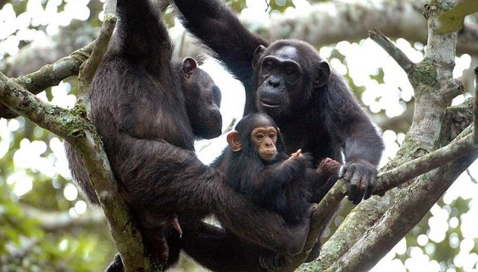Have early morning breakfast before departing to the park headquarters where you will be given a safety and tracking briefing. You will then be taken by vehicle to a starting point, to commence your chimpanzee trek in the forest. After this phenomenal wildlife experience, return to your vehicle on the edge of the forest, returning to Isunga lodge for lunch. Take an afternoon swamp walk in Bigodi swamp sanctuary to sight some birds and other primates. Meal plan: Breakfast, Lunch and Dinner

Accommodation: **Kibale Safari Lodge**

**23rd November 2023: Transfer to Bwindi Impenetrable National Park**

Early breakfast prior to departing for Bwindi via Queen Elizabeth national park and watch out for eye-catching big game on the way like elephants, buffalos, antelopes, warthogs and other wildlife. In the afternoon, relax while having lunch in Kihihi town or take a walk to the bustling market of Kihihi. Continue to Bwindi for ultimate gorilla experience. Meal plan: Breakfast, Lunch and Dinner

Accommodation: **Rushaga Gorilla Haven’s Lodge**

**24th November 2023: Gorilla Habituation Day**

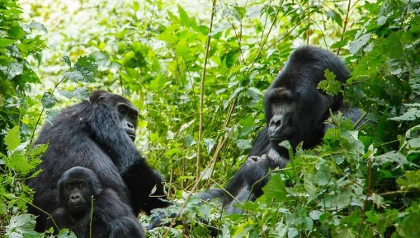Breakfast in the morning, then head to the park headquarters for a briefing on the dos and don'ts of Bwindi gorilla trekking. When you first begin looking for the gentle giants in the rain forest, the rangers will go with you. This walk occasionally requires a lot of strength, therefore it might be difficult. Because the weather is so variable, trekkers are usually encouraged to bring their rain coats and boots. There are also some potters who, for a nominal fee, are always willing to assist visitors with lugging their bags. The rangers will instruct you on how to handle the gorillas once you see them, notably by keeping a 6 meter distance from them as you watch them play. How long gorilla trekking will take is never easy to forecast, and it also relies on where some families are since some of them are located far from the park headquarters. The rangers will always be there to help you, but it always takes 2 to 8 hours to get in touch with them. Prior to monitoring, it is also advised that trackers maintain a [healthy physical condition](https://davsafaris.com/rwanda-safaris). After your hike, head back to the lodge for relaxation, dinner and overnight. Meal Plan: Breakfast, Lunch and Dinner

Accommodation: **Rushaga Gorilla Haven’s Lodge**

**25th November 2023: Golden Monkey Tracking**

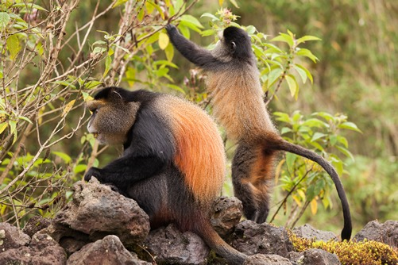On this day, have an early morning breakfast and drive to the park offices for the briefing, there start the golden monkey tracking in the forest. This activity starts at 7 am at the Park headquarters where you will head to the forest with other tourists in search of the endangered Golden monkey. This takes about 4 hours or more of the Golden monkey tracking adventure inclusive of one hour stay near to them where you view them rolling on the Bamboo stems and present themselves with no shyness as it has been worked on through habituation and see the sights of their silver patch. Meal Plan: Breakfast, Lunch and Dinner

Accommodation: Rushaga Gorilla Camp

**26th November 2023: Transfer to Kampala/Kigali or Entebbe**

After breakfast, start on the long drive back to Entebbe / Kampala with the memory of the great rare mountain Apes. Lunch en route and a stopover at the equator line for experimentation, arriving late in the evening to be dropped at Entebbe international airport at approximately 6 pm to check in for your air transfer back home as you say farewell to the pearl of Africa! Meal plan: Breakfast, Lunch

**Quotation:**

|  |
| --- |
| PRICE PER PERSON |
| USD 3550 |

**The Safari Includes:**

* Park fees (For non-residents)
* Gorilla permits (One per person, non-resident)
* Chimp permits (One per person, non-resident)
* All activities (Unless labeled as optional)
* All accommodation (Unless listed as upgrade)
* A professional driver/guide
* All transportation (Unless labeled as optional)
* All Taxes/VAT
* Roundtrip airport transfer
* Meals (As specified in the day-by-day section)
* Drinking water (On all days)

**The Safari Excludes;**

* International flights (From/to home)
* Additional accommodation before and at the end of the tour
* Tips (Tipping guideline US$10.00 pp per day)
* Personal items (Souvenirs, travel insurance, visa fees, etc.)
* Government imposed increase of taxes and/or park fees

**What to prepare for during the Gorilla trekking Activity**

* Bwindi impenetrable national park requires hiking; you should pace yourself and drink plenty of water.
* Eating, drinking and smoking near the gorillas is forbidden. Your ranger guide will communicate designated time and place for such.
* We encourage you to carry a rain poncho
* Waterproof walking shoes or hiking boots are essential.
* Gardening gloves for protection against stinging plants
* Long trousers and long sleeved sweaters or shirts while in the forest to avoid insect stings.
* Photography is permitted, although you must not use flash
* Porters are available to help you carry your day pack for a minimum fee of $20 or UGX 50,000

**Important information**

Gorilla trekking is dependent on the availability of permits at the time of your booking. Gorilla permits in all the national parks of Uganda and Rwanda are in high demand; we advise that you book your tour well in advance to avoid disappointment. If gorilla permits are not available for Bwindi Impenetrable National Park, it’s possible to see the mountain gorillas at Mgahinga Gorilla National Park which is 7 kilometres from the town of Kisoro in Uganda.